Task 25

# Deep Das

Question : print a message when distance of object from ultrasonic sensor is 220m and write about its component list,schematic diagram and working principle.

Answer :

* Working principle :

The working principle of ultrasonic sensors is that it has 2 parts an emitter and a collector part from which the emitter part emits the ultrasonic waves and collector part receives the signal.it calculates the time between emission and collection and from time it gives us a distance by multiplying it with a constant 0.01723 to give us the distance in centimeters.

* Schematic diagram :

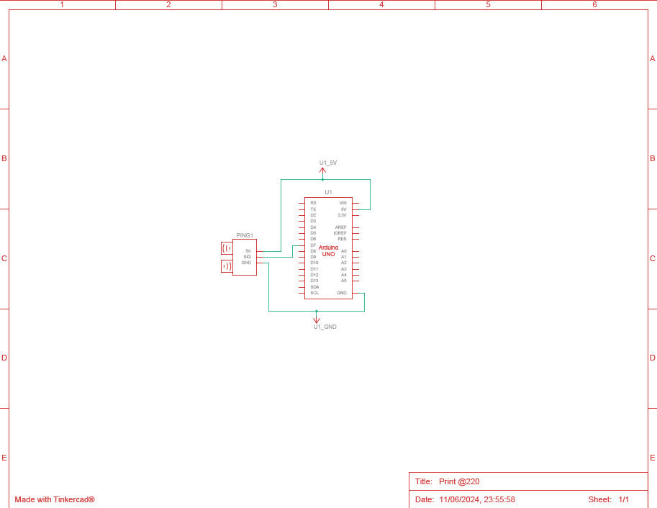

* Component list :

|  |  |  |
| --- | --- | --- |
| Name | Quantity used | Component |
| U1 | 1 | Arduino Uno R3 |
| PING1 | 1 | Ultrasonic Distance Sensor |

* Code :

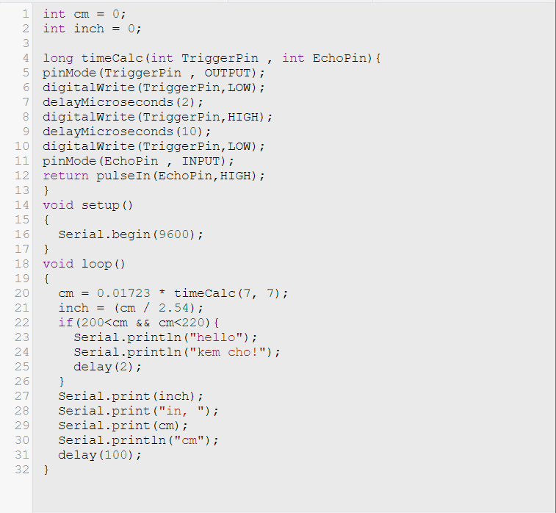

* Output :



* Graph :

